**Issue 4 Proposal**

Working Group One

R.17-07-007

*Issue 4: As the penetration levels of distributed energy resources increase, what changes to telemetry requirements should the Commission adopt to ensure adequate visibility while*

*minimizing cost?*

# Proposal Summary

This is a non-consensus item.

Pacific Gas and Electric Company, Southern California Edison Company and San Diego Gas & Electric Company (collectively, the IOUs) propose:

1. Reduce threshold for requiring telemetry from 1 MWac to 250 kWac only if estimated proposed telemetry solution Telemetery Equipment Cost is less than $20,000[1]; such projects remain responsible for actual cost of the telemetry solution. To provide transparency regarding estimated vs. actual cost of telemetry solution for such projects, the IOUs propose to supplement existing Commission data reporting.
2. Continue to utilize existing Rule 21 telemetry threshold based upon the Generating Facility Nameplate Rating Capacity,[2] which includes the generating facility aggregate nameplate rating capacity (where it includes multiple resources, including storage).
3. Continue to allow IOUs existing flexibility in development of lower cost telemetry solutions in accordance with specific needs.

Non-utility stakeholders propose:

1. Maintain the threshold for requiring telemetry at 1 MWac.
2. Require the IOUs to adopt the following technical requirements for telemetry for systems larger than 1 MWac:

* Facilities can report measurements in 15-minute increments, transmitted daily, using customer-owned, non-revenue-grade metering and a data aggregation and communication device comparable to the serial device server currently required by SCE.[3]
* The facility can use existing smart meters to transmit data to utilities. Alternatively, customers can choose to connect the reporting device to the utility Energy Management System via cellular modem or dedicated internet connection.
* Measurements do not have to be made from revenue grade equipment since the telemetry data is used for operational and planning purposes only. Thus, producers are not required to measure total generation output data from a more costly utility-owned Net Generation Output Meter.

1. Apply the telemetry threshold to the maximum facility export in the interconnection agreement if this value is different from the total nameplate rating of all resources on the site.
2. Do not apply the telemetry requirement to customers for which the All-In Cost would exceed $20,000.[4]
3. Customer ownership of behind-the-meter telemetry equipment should be allowed where practicable to avoid federal tax for Income Tax Component of Contribution (ITCC) and cost of ownership (COO) charges. Maintenance of the equipment and required uptime metrics will be specified in the interconnection agreement.

# Background

Telemetry involves the real-time transmittal of information from a resource on the distribution system to the utilities. Rule 21 currently allows utilities to require distributed energy resources (DERs) larger than 1 MWac to provide telemetry.[5] This data can include how much a solar system is producing, how much reactive power the system is producing or absorbing, how much a battery is charging or discharging, and voltage conditions.

The IOUs believe that increased use of telemetry is necessary to allow for grid visibility for the safe and reliable operation of the electrical grid with the continued proliferation of DERs. The current 1 MWac Rule 21 telemetry threshold was established when relatively few DERs were on the grid and the overall level of DER penetration was not significant in comparison to total load.

Without the use of telemetry, the IOUs have no real-time visibility or situational awarenessof projects connected to the utility’s grid and related safety and reliability needs. In particular, telemetry addresses the concern of “load masking,” which describes a situation in which the lack of system visibility undermines electrical system planning assumptions due to a difference between “real” electrical load vs. actual net electrical load (e.g., the daytime electrical load on an electrical circuit may actually be served by on-site generation but the utility is required to service the electrical load if the on-site generation is not able to).

Both the IOUs and stakeholders acknowledge that telemetry costs in some cases have been cost prohibitive, especially for PG&E customers. Recognizing this issue, the IOUs have continued to look for more cost effective solutions. Stakeholders represent that based on current projects, telemetry costs have ranged from $10,000-$250,000. Based upon IOU review, costs have generally ranged from $20,000-$180,000.

See Appendix B for a detailed description of the current utility requirements for telemetry. The costs are summarized below:

* SCE’s current approach to telemetry costs approximately $20,000 all-in.[6]
* PG&E’s current approach costs producers approximately $160,000 all-in. PG&E requires large circuit breakers called reclosers that can be controlled remotely. The main purpose of this device is to provide grid protection when the utility has reason to believe there is risk of inappropriate power flow. However, the circuit interruption functionality is not needed for the purpose of telemetry. PG&E has used this approach because it is a reliable device that has communications. PG&E is exploring a pilot approach similar to SCE, but it is in progress.
* SDG&E’s approach requires a dedicated leased line that can cost $100,000-$250,000 all-in. They have expressed willingness to explore a cheaper approach comparable to SCE but have not developed such an approach.

Telemetry is one of the functions that were considered by the Smart Inverter Working Group, which was co-sponsored by the Commission and the California Energy Commission. The Phase 3 recommendations of that group include a requirement that generating facilities be capable of reporting operating data. Many stakeholders have incorrectly thought that smart inverters will make telemetry cheap and easy once the new functions are enabled. However, that is not the case.

Utility telemetry rules require reporting facility-level data rather than inverter-level data. A majority of customer-sited solar installations have multiple inverters, and the required inverter communications functionality therefore may not reduce the costs of providing telemetry for customers. It is not as simple as turning on the communications capabilities that will be designed into inverters. The solar provider will have to aggregate and report the data, which cannot be done by the inverters themselves.

More background on this issue is contained in the appendices to this proposal.

# Working Group Proposals

## A. Utilities

As highlighted within Section II, without the use of telemetry, the IOUs have limited system visibility or situational awareness for DERs under 1 MWac. This lack of visibility impedes the IOUs’ electrical planning assumptions in relation to DER load as the IOUs maintain the obligation to serve in cases where the DER is not available (see Appendix A for operational use cases). Therefore, the IOUs propose the following revisions to the existing Rule 21 1 MWac telemetry requirement.

1. ***Reduce threshold for requiring telemetry from 1 MWac to 250 kWac if proposed telemetry solution All-In Cost is less than $20,000[7] to address lack of current DER visibility interconnected under Rule 21***

As highlighted within Section II, without the use of telemetry, the IOUs have limited system visibility or situational awareness for DERs under 1 MWac. For example, at higher levels of penetration, the lack of DER visibility contributes to operational awareness issues, which then leads to real time operational system concerns. Also, the lack of DER visibility impedes the IOUs’ electrical planning in relation to DER load as the IOUs maintain the obligation to serve in cases where the DER is not available. For example, the vast majority of Rule 21 projects are interconnected within SCE’s territory without telemetry. Although the vast majority of Rule 21 projects are of a small project size, the aggregate amount of projects totals to **xx** generation to which SCE has no real time system visibility or situational awareness. In addition, as presented during working group discussions, looking at SCE’s service territory, lowering of the telemetry threshold to 250 kW would impact approximately four percent of Rule 21 projects but would provide an additional sixteen percent distribution capacity visibility (SCE historical data shows that approximately 250 additional projects annually would be subject to telemetry if the telemetry requirement was reduced to 250 kW).

The sophistication of telemetry solutions has improved and is expected to continue to do so. For example, PG&E has made progress in developing telemetry options that are expected to meet the All-In Cost of $20,000 or less. SCE also had developed cost effective solutions that are also expected to meet the $20,000 cost threshold. Telemetry costs have been a major decision point in whether the lowering of the telemetry threshold was appropriate at this time.[8] Finally, the use of telemetry is common today throughout transmission level interconnections and although DER telemetry from all projects would be viewed as optimal, the IOUs believe they have continued to balance the need for system visibility vs. appropriate project size and related cost pressures.

1. ***Continue Existing Size Determination for Rule 21 Telemetry Generating Facility Threshold Requirement (aggregate nameplate rating capacity of the Generating Facility where it includes multiple DERs) to effectively address lack of IOU load visibility***

IOUs propose that no changes be made to the Rule 21 requirement that telemetry is based on the aggregate generating facility amount, with any storage device counted as a generator at its full capacity. The most common concern that the IOUs have (as echoed by the California Independent System Operator) is the issue of “load masking,” which is the circumstance of when load that is serviced by the DER is not visible to the IOU, but the IOUs remain required to service electrical load in cases when DER is not available. Both non-exporting and exporting resources are capable of masking load. The amount of generation in relation to load determines how great the load masking issue is, and when it becomes critical. While load masking could be estimated based on Generating Facility nameplate, the actual output of these generating facilities can vary greatly and is not sufficient to determine real time operational decisions, including system contingencies. It is important to remain aware of what amount of generation is occurring in addition to load. For example, this issue becomes critical in the situation when an electrical feeder circuit experiences a momentary fault and inverters trip offline. The feeder circuit breaker recloses automatically to restore load but inverters are required to have a short time delay to return so that it does return until the feeder’s voltage and frequency are stabilized. During this short time, the unmasked load will appear, potentially overloading the feeder and creating subsequent outage. Real time visibility via telemetry can help the IOU plan for these situations, facilitate the identification of the masked load situation, with the result that electrical service can be restored to customers more expeditiously.

1. ***Continue Existing IOU Flexibility in Development of Cost Effective Solutions***

Current Rule 21 telemetry requirements are based on project system size as compared to telemetry solution. As the revised telemetry requirement would not be not triggered until the solution’s All-In Cost is lowered to $20,000 or below. It is critical that the IOUs have enough flexibility in order to reach the telemetry cost goals and may have different Operations Distribution Networks (ODN) and SCADA systems that leverage different communication protocols (DNP3 or secure DNP3). For these reasons, the communication options and hardware necessary to communicate with infrastructure and software for each IOU operations may not be the same. However, as consistent with today’s practices, even with these slight variations, all three IOUs share the same telemetry needs today along with obligations to meet cybersecurity and operations related functions.

## B. Non-Utility Stakeholders

Operational data can be reported to utilities in a manner that is far less expensive than what has been required of many customers. Even at a controlled cost, the Commission must ensure that the benefits outweigh the costs.

1. Maintain the threshold for requiring telemetry at 1 MWac.

Non-utility stakeholders believe the IOUs have not shown the need for real-time data for systems smaller than 1 MW. Additionally, non-utility stakeholders remain very concerned about the implications on project economics of reducing the telemetry threshold, especially when the technical requirements are still not settled. Any consideration of reducing the threshold for the telemetry requirement will have to clearly consider the costs and benefits of doing so and the implications on project economics.

1. Require the IOUs to adopt the following technical requirements for telemetry for systems larger than 1 MWac:

* Facilities can report measurements in 15-minute increments, transmitted daily, using customer-owned, non-revenue-grade metering and a data aggregation device comparable to the remote terminal unit currently required by SCE.
* The facility can use existing smart meters to transmit data to utilities. Alternatively, customers can choose to connect the reporting device to the utility Energy Management System via cellular modem or dedicated internet connection.
* Measurements do not have to be made from revenue grade equipment since the telemetry data is used for operational and planning purposes only. Thus, producers are not required to measure total generation output data from a more costly utility-owned Net Generation Output Meter.

The most important element of Issue 4 is to require both PG&E and SDG&E to match SCE’s current technical requirements and practices, which allow a system larger than 1 MWac to provide telemetry for an All-In Cost of approximately $20,000.

Non-utility stakeholders appreciate that the IOUs are considering termination of previous technology requirements for cost control purposes, but the IOU proposal does not commit to any cost control for systems larger than 1 MWac. There must be either a cost cap or clear technology parameters that are intended to meet a target cost.

In addition, this proposal leverages the existing Advanced Metering Infrastructure (smart meters) that customers paid billions of dollars to install. Part of the reasoning behind making the smart meter investment was for “Management of distributed energy resources” and to obtain “situational data in near real time.”[9]

*IOU response: Please refer to Sections III.A.1 and III.B.2 from IOU Response*

1. Apply the telemetry threshold to the maximum facility export in the interconnection agreement if this value is different from the total nameplate rating of all generation on the site.

Utilities have clarified that the threshold for telemetry is based on the sum of nameplate capacities of all inverters (summing solar and storage inverters). In cases where a maximum facility export is included in the interconnection agreement, utilities have not been using that lower number for this purpose. For example, in cases where a non-export or reverse power relay limits facility export below the total nameplate, the total nameplate is still used as the threshold for requiring telemetry.

If a customer has a 700 kW solar system and a 400 kW storage system, current utility practice considers this an 1100 kW system even if the storage is configured in a way that will never export to the grid or if there are operating requirements that limit export to 50 kW. If a system export capacity is stipulated in the interconnection agreement that is different from the sum of the nameplate capacities, that value should be used for determining whether the telemetry threshold is exceeded

1. Telemetry should not be required for systems smaller than 10 MW if the All-In Cost would exceed $20,000.

The IOUs appear to agree for systems smaller than 1 MW but not for systems larger than 1 MW. The reason that non-utility stakeholders urged the Commission to address this issue in this proceeding is because the cost of telemetry for systems larger than 1 MW has been onerous in many cases. Controlling those costs is the largest issue under consideration.

*IOU response: As discussed within Section III.A.1, the IOU proposal for a reduced telemetry threshold would not be triggered unless the All-In Cost of telemetry is less than or equal to $20,000.*

1. Customer ownership of behind-the-meter telemetry equipment should be allowed where practicable to avoid federal tax for Income Tax Component of Contribution (ITCC) and cost of ownership (COO) charges.

DER developers understand that maintenance of equipment and required uptime metrics will be specified in the interconnection agreement, but cost of ownership charges and ITCC are so high that customers should be permitted to maintain systems on their own.

*IOU response: Cost of ownership and ITCC are charges tied to the IOU procuring, installing, and maintaining equipment necessary to meet telemetry requirements. Stakeholders should be required to provide proposals on how equipment will be maintained not just through warranty periods but beyond in order for an alternate proposal if customer ownership should be considered. The IOUs shared concerns on post installation whether account owners or installers would be in a position to detect equipment failure and how quickly they will be able to repair equipment.*

1. Utilities and DER providers should explore annual data reporting for systems smaller than 1 MWac.

Utilities use data from DERs for operational and planning purposes. Data for operational considerations may be needed in real time. Data for planning like the load masking issue could be reported in monthly or annual communications. In some cases where real time data is needed, sufficient data may be available from existing smart meters. See Appendix A for more on the different utility uses of DER data.

Non-utility stakeholders recognize that data from smaller systems would be beneficial for planning purposes, but the benefit does not support a cost of $20,000 per system. Utilities should develop a process for annual reporting.

*IOU response: This could impose significant costs to the IOUs. All telemetry data currently filters into a single system tied to Utility Operations. Standalone data reports would need to be processed in order to feed into that single system which would impose material costs. This could be mitigated by controlling the format such that all DER providers would be required to comply with but other costs would be incurred to maintain compliance with this requirement. It is also undetermined which DER providers would be required to participate.*

# Appendix A. Operational and Distribution Planning Telemetry Uses

In accordance with Section C of Rule 21, telemetry refers to the technology that transmits generator or DER data to the utility. This information is provided on a real time basis primarily for operations related purposes as highlighted below:

1. **Temporary Connection** – In some cases, generators are granted permission to operate with operational conditions. Telemetry information is used to monitor the generator’s compliance and whether any reliability concerns may surface.
2. **Moving Load Between Electrical Circuits (“Switching”)** – Circuits a generator is tied into may need to be switched, which currently limits a DER’s operations. Telemetry information may facilitate the Distribution Provider’s allowance of a DER to remain operational in an abnormal configuration.
3. **Diagnostics** – In the event of an outage or system disturbance, telemetry information along with grid operational data can be analyzed to diagnose what may have triggered the event. Without telemetry, utility personnel may need to physically diagnose the situation.
4. **Planning** – With the growth of DERs, the difference between true load vs the net load is becoming a non-trivial amount. The utility needs to understand the amount of load that aggregate DERs on a feeder are serving or often termed as “masking” to plan for total load. A utility has an obligation to serve and in the event a DER is not available the utility must provide “standby service” to be able to serve the load that particular DER is offsetting.
5. **Automatic Reclosing/Restoration** – When an electric feeder experiences a disturbance, DERs on the feeder trip offline. Upon correction of the system disturbance, the line is re-energized but there typically is a delay before DERs come back online. During this time, the load the aggregate DERs were serving is no longer “masked.” The utility leverages telemetry data to plan and reserve capacity for this atypical scenario. The absence of this planning can lead to further system disturbances.
6. **Operation Switching** – For planned or unplanned maintenance work, feeders or line sections must be de-energized to allow work to be performed. Telemetry information is utilized to determine total load, including load that may be “masked” by local DERs, and determine if that load can be adequately served from a different source.

Non-utility stakeholders make the following observations on these use cases:

* Use cases 1 and 2 are optional to the customer. Telemetry could be required solely for customers utilizing these options.

*IOU Response: Without real time data, IOUs have to assume conservative planning values that diminishes the use of operational flexibility. The increase in DERs without telemetry further compounds this issue and could contribute to electrical restoration delays and reliability.*

* Use cases 4 and 5 can be achieved with monthly or annual data reporting rather than real time telemetry.

*IOU Response: It is difficult and very labor intensive for IOUs to gather and correlate large amount of various monthly or annual generation data from DERs to determine what may be accurate “masked load.” With the use of real time constant telemetry data from DERs, utilities can accurately and efficiently “masked load” and plan capacity needs accordingly in the absence of DERs.*

* For use case 6, utilities likely use planning values rather than real time data when making decisions about switching operations.

*IOU Response: As discussed in responses in use cases 1 and 2 above, without the use of real time data, IOUs have to assume conservative planning values that diminishes the use of operational flexibility. This could potentially delay restoring electrical service to customers. As more DERs are placed on the electrical grid, this issue is further compounded.*

# Appendix B. Current Telemetry Requirements

# Summary of Utility Requirements and Current Philosophies on Telemetering

|  |  |  |  |
| --- | --- | --- | --- |
|  | SCE | SDG&E | PG&E |
| Source of Measurements | Permits measurements from customer owned meter / data acquisition system that is already incorporated into design (no incremental equipment required) | Requires installation of additional utility owned meter in customer owned metering enclsousre (e.g. Net Generation Output Meter aka NGOM. | Requires utilty owned recloser to measure net export. In future, will likely propose same approach as SDG&E with utility owned meter |
| Telemetering Equipment / System | Permits customer owned equipment (e.g. modem like device). | Requires utility ownership of telemetering equipment. | Requires utility ownership of telemetering equipment. |

**Example All-In Cost Range for Producer to Provide Telemetry**

**Background on Cost Tables**

[add introductory commentary]



[Placeholder Illustration of two major components of providing telemetry – meant to illustrate the differences in approach to ownership of the full telemetering solution (both 1) Measurement Equipment and 2) Telemetering Equipment)]

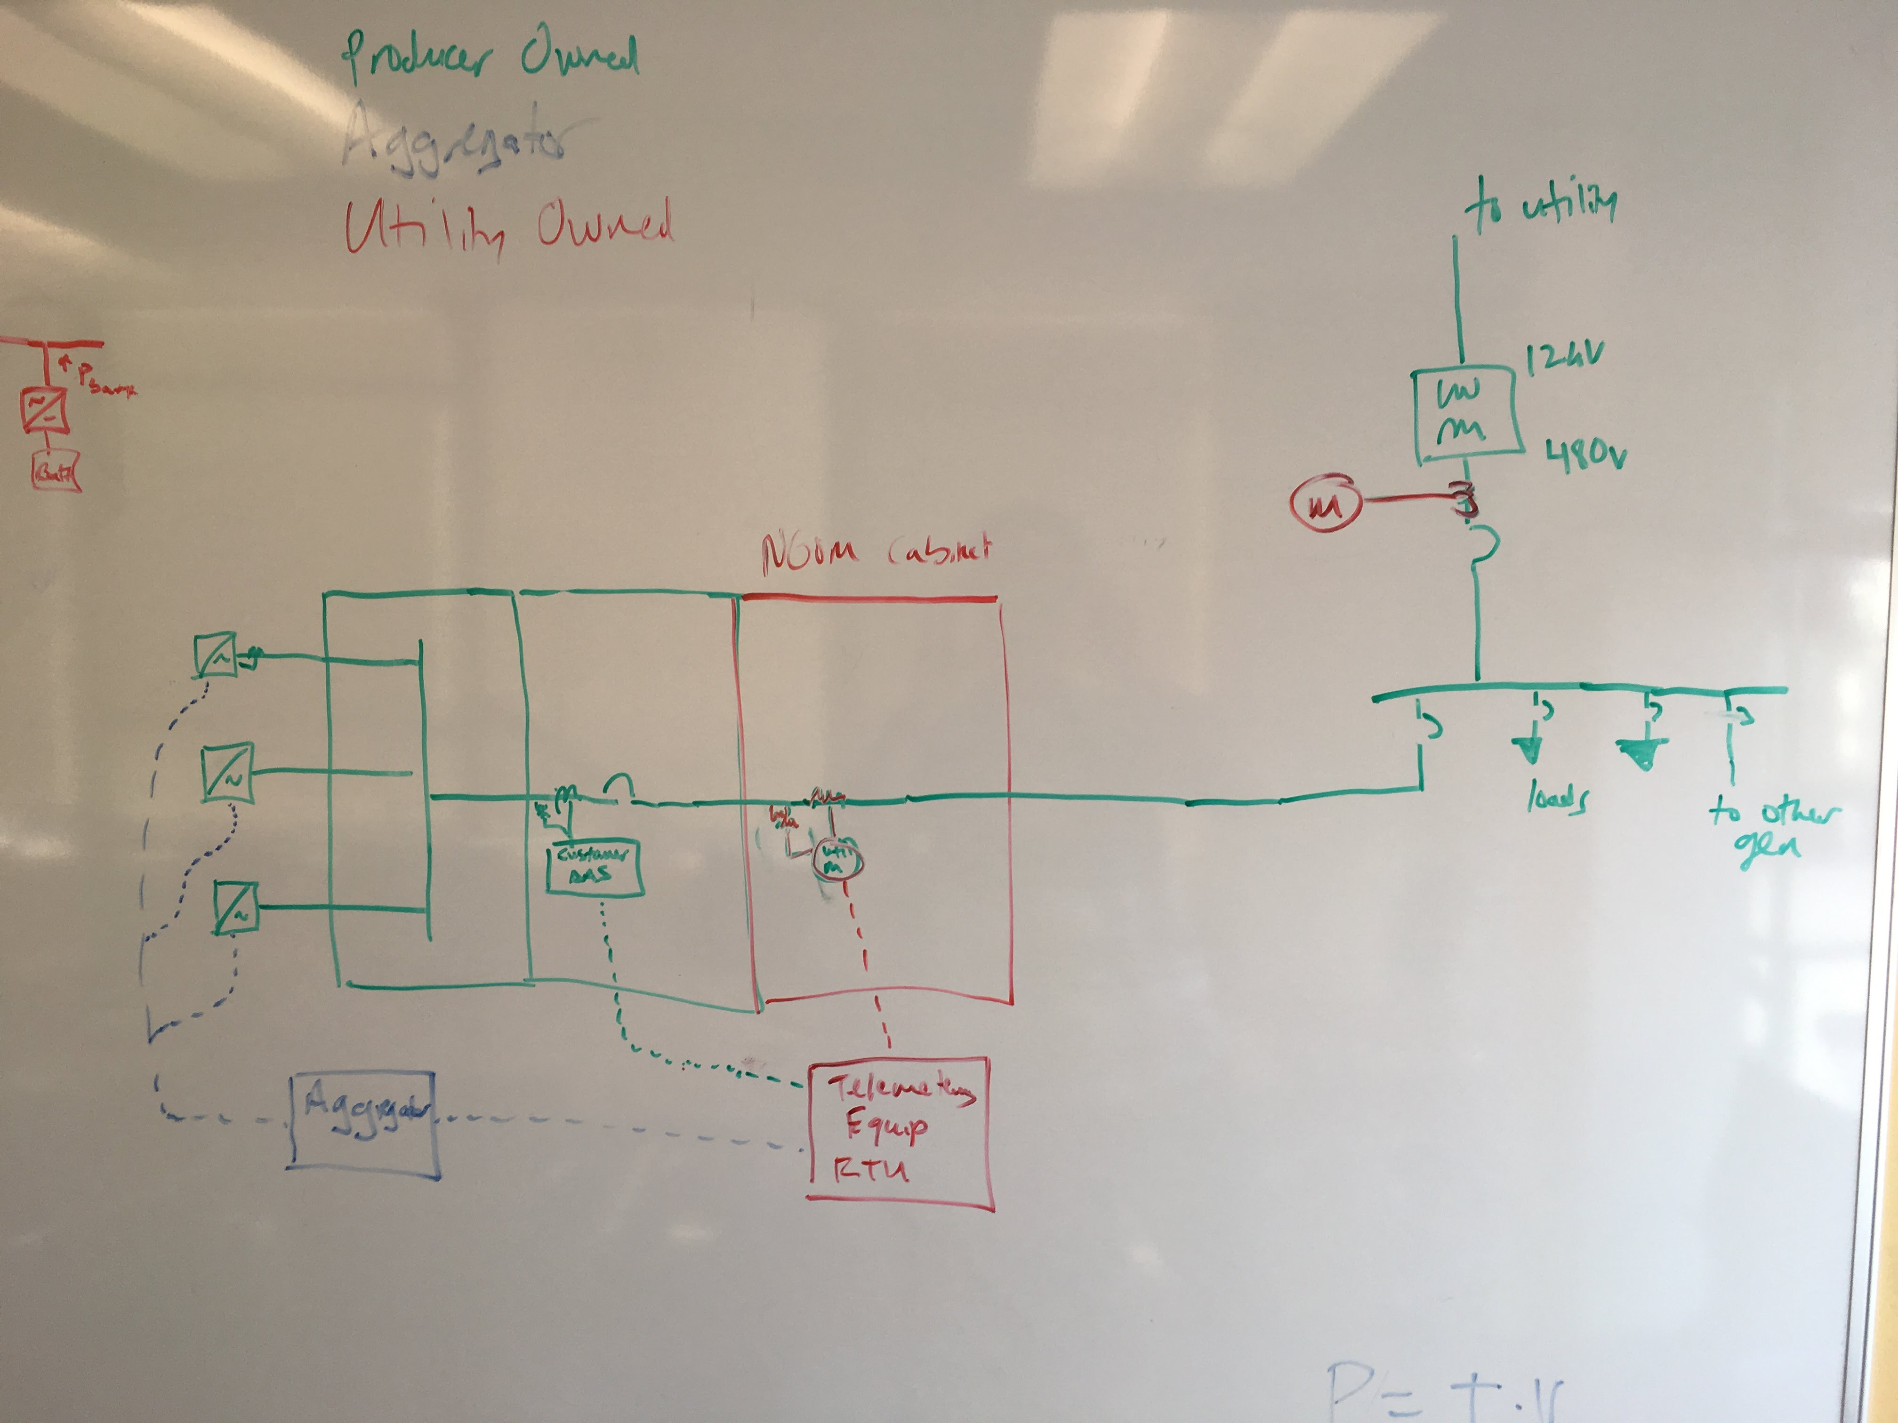

**Summary of All-In Incremental Cost Range to Provide Telemetry by Utility**

[add introductory commentary]

Cost of Ownership (COO) and Income Tax Component of Contribution (ITCC) are calculated separately where applicable to ensure consistency and to demonstrate the magnitude of those items.

[see below and attached spreadsheet for breakdown of Total Incremental Cost to Producer as well as assumptions and source of those costs]



**Conceptual Illustration of cost burden on project for All-In Incremental Cost to Provide Telemetry**









1. The $20,000 cost would include the cost to acquire and transmit real-time generation output data to the utility in compliance with applicable security requirements. It would include O&M and ITCC related costs. For purposes of this proposal these costs as a group are defined as “Telemetry Equipment Costs.”
2. Generating Facility Nameplate Rating Capacity: The net capacity of the Generating Facility and the aggregate net capacity of the Generating Facility where it includes multiple Generators.
3. See <https://store.perle.com/iolansds1ta4d2> for the Serial Device Server SCE currently requires.
4. For purposes of this proposal, the “All-In Cost” is the Telemetering Equipment Cost, as defined above, plus the metering equipment.
5. Rule 21, Section J.5 (Telemetering). This section also allows the IOUs to require telemetry for smaller systems if they are on a circuit with voltage below 10 kV, but this is a small portion of the distribution system.
6. This is less than $10,000 if it is customer-owned and the customer does not pay cost of ownership charges and ITCC.
7. The $20,000 cost would include the cost to acquire and transmit real-time generation output data to the utility in compliance with applicable security requirements. It would include operations and maintenance and ITCC related costs. It would not include metering costs such as current transformers, potential transformers, or generator output meters. For purposes of this proposal these costs as a group are defined as “All-In Costs.”
8. As discussed within Working Group discussions, discussions remain underway in support of Smart Inverter Working Group, including forms and agreements that would address aggregator or aggregator akin use in support of Smart Inverter capabilities. This discussion is slated for additional discussion within Working Group Two. For purposes of this proposal, refined telemetry solutions have been focused upon and their associated cost.
9. SCE, “AMI Overview and Metering Framework,” May 2, 2006.