**Issue 4 Proposal**

Working Group One

R.17-07-007

*Issue 4: As the penetration levels of distributed energy resources increase, what changes to telemetry requirements should the Commission adopt to ensure adequate visibility while*

*minimizing cost?*

# Proposal Summary

This is a non-consensus item.

Pacific Gas and Electric Company, Southern California Edison Company and San Diego Gas and Electric Company (collectively, the IOUs) propose:

1. Reduce threshold for requiring telemetry from 1 MWac to 250 kWac if proposed telemetry solution is less than $20,000[1]
2. Continue to utilize existing Rule 21 telemetry threshold based upon the Generating Facility Capacity,[2] which includes the generating facility aggregate net capacity (where it includes multiple generators)
3. Continue to allow IOU existing flexibility in development of lower cost telemetry solutions in accordance with specific needs

Non-utility stakeholders propose:

1. Maintain the threshold for requiring telemetry at 1 MWac.
2. Require the IOUs to adopt the following technical requirements for telemetry:

* Facilities can report measurements in a way that is consistent with the current best practice from SCE. This involves a customer-owned data acquisition system with a hard-wired serial connection to a Serial Device Server that uses a Virtual Private Network tunnel via a dedicated internet connection.
* The facility reporting device can be connected to the utility Energy Management System via cellular modem or dedicated internet connection.

1. Apply the telemetry threshold should apply to the maximum facility export in the interconnection agreement if this value is different from the total nameplate rating of all generation on the site.
2. Eliminate telemetry requirement the All-in Cost would exceeds $20,000.

# Background

From the IOU’s viewpoint, as the IOUs are responsible for the safe and reliable operation of the electrical grid, the increased use of telemetry is necessary to allow for grid visibility with the continued proliferation of Distribution Energy Resources (DERs). By way of background, the current 1 MWac Rule 21 telemetry threshold[3] was established when very few DERs were on the grid and the overall level of DER penetration was not significant in comparison to total load. Without the use of telemetry, the IOUs have no real-time oversight or situational awarenessof projects connected to the utility’s grid and related safety and reliability needs. In particular, telemetry addresses the concern of “load masking,” which describes a situation to where the lack of system visibility undermines electrical system planning assumptions as the difference between “real” electrical load vs. actual net electrical load (e.g., the daytime electrical load on an electrical circuit may actually be served by on-site generation but the utility is required to service the electrical load if the on-site generation is not able to).

Both the IOUs and stakeholders acknowledge that legacy telemetry costs have been viewed as cost prohibitive in particular for smaller units. Recognizing this issue, the IOUs have continued to look for more cost effective solutions as incorporated within the IOU proposal. Stakeholders represent that based on current projects, typical telemetry costs have ranged from $20,000-$250,000. Based upon IOU review, costs have generally ranged from $20,000-$180,000.

# Working Group Proposals

## IOU Proposal

As highlighted within Section II, without the use of telemetry, the IOUs have limited system visibility or situational awareness for DERs under 1 MWac. This lack of visibility impedes the IOUs’ electrical planning assumptions in relation to DER load as the IOUs maintain the obligation to serve in cases where the DER is not available (see Appendix A for operational use cases). Therefore, the IOUs propose the following revisions to the existing Rule 21 1MW telemetry requirement:

1. *Reduce Rule 21 Telemetry Requirement from 1 MW or Greater to 250 kW or Greater if Proposed Telemetry Solution All-in Cost is $20,000 or less*
2. *Continue to Utilize Existing Rule 21 Telemetry Threshold Requirement of Generating Facility Capacity*[4] *(includes the aggregate net capacity of the Generating Facility where it includes multiple generators)*
3. *Continue to Allow IOUs Flexibility in Development of Cost Effective Telemetry Solutions*
4. ***Reduce threshold for requiring telemetry from 1 MWac to 250 kWac if proposed telemetry solution All-in Cost is less than $20,000[5] to address lack of current DER visibility interconnected under Rule 21***

As highlighted within Section II, without the use of telemetry, the IOUs have limited system visibility or situational awareness for DERs under 1 MWac. This lack of visibility impedes the IOUs’ electrical planning assumptions in relation to DER load as the IOUs maintain the obligation to serve in cases where the DER is not available. For example, the vast majority of Rule 21 projects are interconnected within SCE’s territory without telemetry (Enright will confirm 99.9 percentage prior to final report). Although the vast majority of Rule 21 projects are of a small project size, the aggregate amount of projects totals to **xx (**Enright to confirm prior to final report) generation to which SCE has no real time system visibility or situational awareness. In addition, as presented during working group discussions, looking at SCE’s service territory, lowering of the telemetry threshold to 250kW would impact approximately four recent of Rule 21 projects but would provide an additional sixteen percent distribution capacity visibility (SCE historical data shows that approximately 250 additional projects annually would be subject to telemetry if the telemetry requirement was reduced to 250kW).

The sophistication of telemetry solutions have improved and are expected to continue to do so. For example, PG&E has made progress in developing telemetry options that are expected to meet the All-in Cost of $20,000 or less. SCE also had developed cost effective solutions that are also expected to meet the $20,000 cost threshold. Telemetry costs have been a major decision point in whether the lowering of the telemetry threshold was appropriate at this time.[6] Finally, the use of telemetry is common today throughout transmission level interconnections and the IOUs have continued to balance the need for system visibility vs. appropriate project size and related cost pressures.

1. ***Continue Existing Rule 21 Telemetry Generating Facility Threshold Requirement (aggregate net capacity of the Generating Facility where it includes multiple generators) to effectively address lack of IOU load visibility***

IOUs propose that no changes be made to the Rule 21 requirement that telemetry is based on the aggregate generating facility amount. The most common concern that the IOUs have (as echoed by the California Independent System Operator is the issue of “load masking”, which is the circumstance of when load that is serviced by the DER is not visible to the IOU. Both non-exporting and exporting are capable of masking load. The amount of generation in relation to load determines how great the load masking issue is, and when it becomes critical. While load masking could be estimated based on Generating Facility nameplate, the actual output of these generating facilities can vary greatly. It is important to remain aware of what amount of generation is occurring in addition to load. For example, this issue becomes critical in the situation when an electrical feeder circuit experiences a momentary fault and inverters trip offline. The feeder circuit breaker recloses automatically to restore load but inverters are required to have a short time delay to return so that it does return until the feeder’s voltage and frequency are stabilized. During this short time, the unmasked load will appear potentially overloading the feeder and creating subsequent outage. Real time visibility via telemetry can help the IOU plan for these situations, facilitate the identification of the masked load situation, with the result that electrical service can be restored to customers more expeditiously.

1. ***Continue Existing IOU Flexibility in Development of Cost Effective Solutions***

Current Rule 21 telemetry requirements are based on project system size as compared to telemetry solution. As the revised telemetry requirement is not triggered until the solution’s All-in Cost is lowered to $20,000 or below. It is critical that the IOUs have enough flexibility in order to reach the telemetry cost goals and may have different Operations Distribution Networks (ODN) and SCADA systems that leverage different communication protocols (DNP3 or secure DNP3). For these reasons, the communication options and hardware necessary to communicate with infrastructure and software for each IOU operations may not be the same. However, as consistent with today’s practices, even with these slight variations, all three IOUs share the same telemetry requirements today along with obligations to meet cybersecurity and operations related functions.

## B. Non-Utility Stakeholders

Non-utility stakeholders believe the IOUs have not shown the need for real-time data for systems smaller than 1 MW. Additionally, non-IOU stakeholders remain very concerned about the implications on project economics of reducing the telemetry threshold, especially when the technical requirements are still not settled and the costs any such requirement may engender are uncapped. DER providers are comfortable sharing data for a wider universe of customers when doing so does not impose material costs. Any consideration of reducing the threshold for the telemetry requirement will have to clearly consider the costs and benefits of doing so and the implications on project economics.

1. Maintain the threshold for requiring telemetry at 1 MWac.
2. Require the IOUs to adopt the following technical requirements for telemetry:

* Facilities can report measurements in a way that is consistent with the current best practice from SCE. This involves a customer-owned data acquisition system with a hard-wired serial connection to a Serial Device Server that uses a Virtual Private Network tunnel via a dedicated internet connection.
* The facility reporting device can be connected to the utility Energy Management System via cellular modem or dedicated internet connection.

*IOU response: Please refer to Sections III.A.1 and III.B.2 from IOU Response*

1. Apply the telemetry threshold to the maximum facility export in the interconnection agreement if this value is different from the total nameplate rating of all generation on the site.
2. Telemetry should not be required if the all-in cost would exceed $20,000.

*IOU response: As discussed within Section III.A.1, the IOU proposal would not be triggered unless the All-in Cost telemetry cost is less or equal to $20,000 (including ITCC and Cost of Ownership). Cost of ownership and ITCC are charges tied to the IOU procuring, installing, and maintaining equipment necessary to meet telemetry requirements. Stakeholders should be required to provide proposals on how equipment will be maintained not just through warranty periods but beyond in order for an alternate proposal of customer ownership should be considered. The IOUs shared concerns on post installation whether account owners or installers would be in a position to detect equipment failure and how quickly they will be able to repair equipment.*

1. Utilities and DER providers should explore annual data reporting for systems smaller than 1 MWac.

The most important element of this issue is to require both PG&E and SDG&E to match SCE’s current technical requirements and practices, which allow a system larger than 1 MWac to provide telemetry for approximately $20,000 all-in. Non-utility stakeholders recognize that data from smaller systems would be beneficial for planning purposes, but the benefit does not support a cost of $20,000 per system. Utilities should develop a process for annual reporting.

*IOU response: Non-Utility stakeholders note above that “DER providers are comfortable sharing data for a wider universe of customers when doing so does not impose material costs.” The IOUs share this concern. Telemetry data currently filters all into a single system tied to Utility Operations. Standalone data reports would need processed in order to feed into that single system which would impose material costs. This could be mitigated by controlling the format such that all DER providers would be required to comply with but other costs would be incurred to maintain compliance with this requirement. It is also undetermined on who would be the DER providers who would participate.*

How the threshold is calculated is an important issue for customers that install non-export or limited-export storage systems. If a customer has a 700 kW solar system and a 400 kW storage system, current utility practice considers this an 1100 kW system even if the storage is configured in a way that will never export to the grid or if there are operating requirements that limit export to 50 kW. If a system export capacity is stipulated in the interconnection agreement that is different from the sum of the nameplate capacities, that value should be used for the determining whether the telemetry threshold is exceeded.

*IOU response: As discussed above within Section III.A.2, load masking is one of the primary concerns that telemetry is addressing. The storage system although configured to not export across the point of common coupling, is still servicing load that is masked from IOU operations.*

# Appendix A. Operational and Distribution Planning Telemetry Uses

In accordance with Section C of Rule 21, telemetry refers to the technology that transmits generator or DER data to the utility. This information is provided on a real-time basis primarily for operations related purposes as highlighted below:

1. **Temporary Connection** – In some cases, generators are granted permission to operate with operational conditions. Telemetry information is used to monitor the generator’s compliance and whether any reliability concerns may surface.
2. **Moving Load Between Electrical Circuits (“Switching”)** – Circuits a generator is tied into may need to be switched, which currently limits a DER’s operations. Telemetry information may facilitate the Distribution Provider’s allowance of a DER to remain operational in an abnormal configuration.
3. **Diagnostics** – In the event of an outage or system disturbance, telemetry information along with grid operational data can be analyzed to diagnose what may have triggered the event. Without telemetry, utility personnel may need to physically diagnose the situation.
4. **Planning** – With the growth of DERs, the difference between true load vs the net load is becoming a non-trivial amount. The utility needs to understand the amount of load that aggregate DERs on a feeder are serving or often termed as “masking” to plan for total load. A utility has an obligation to serve and in the event a DER is not available the utility must provide “standby service” to be able to serve the load that particular DER is offsetting.
5. **Automatic Reclosing/Restoration** – When an electric feeder experiences a disturbance, DERs on the feeder trip offline momentarily (DERs have historically been designed to trip offline momentarily once a system disturbance is detected vs. “riding through” (a condition that a DER should not contribute to). Upon correction of the system disturbance, the line is re-energized but there typically is a delay before DERs come back online. During this time, the load the aggregate DERs were serving is no longer “masked.” The utility leverages telemetry data to plan and reserve capacity for this atypical scenario. The absence of this planning can lead to further system disturbances.
6. **Operation Switching** – For planned or unplanned maintenance work, feeders or line sections must be de-energized to allow work to be performed. Telemetry information is utilized to determine total load, including load that may be “masked” by local DERs, and determine if that load can be adequately served from a different source.

**Non-utility stakeholders make the following observations on these use cases:**

* **Stakeholder Observation:** Use cases 1 and 2 are optional to the customer. Telemetry could be required solely for customers utilizing these options.
* **IOU Response**: Without real time data, IOUs have to assume conservative planning values that diminishes the use of operational flexibility. The increase in DERs without telemetry further compounds this issue and could contribute to electrical restoration delays and reliability.
* **Stakeholder Observation**: Use cases 4 and 5 can be achieved with monthly or annual data reporting rather than real time telemetry.
* **IOU response:** It is difficult and very labor intensive for IOUs to gather and correlate large amount of various monthly or annual generation data from DERs to determine what may be accurate “masked load.” With the use of real time constant telemetry data from DERs, utilities can accurately and efficiently “masked load” and plan capacity needs accordingly in the absence of DERs.
* **Stakeholder Observation:** For use case 6, utilities likely use planning values rather than real time data when making decisions about switching operations.
* **IOU Response:** As discussed in responses in use cases 1 and 2 above, without the use of real time data, IOUs have to assume conservative planning values that diminishes the use of operational flexibility. This could potentially delay restoring electrical service to customers. As more DERs are placed on the electrical grid, this issue is further compounded.

# Appendix B. Current Telemetry Requirements

**Table B-1. Summary of Telemetry Requirements**

|  | **SCE** | **SDG&E** | **PG&E** |
| --- | --- | --- | --- |
| **Physical Measurements Required**  1=Net facility load (e.g. net export)  2=Total generation output | **Current:**  For less than 10 MW only #2 required, #1 not required. | **Current:**  #2 required for all NEM generators larger than the telemetering threshold (currently 1 MW). | **Current:**  Requires #1  **Under Consideration:**  Upon adoption of pending cheaper solution, will require #2 only (total generation output). |
| **Source of Measurements and Ownership of Measuring Equipment** | **Current:**  Source can be producer-owned data acquisition system. Does not need to be revenue grade equipment --e.g. Net Generation Output Meter (NGOM) not required. Customer data acquisition system and data logger can be connected via serial connection directly to Serial Device Server.  **Under Consideration:**  Plans to replace Serial Device Server with alternative, but serial connection from customer owned data logger will still be acceptable. | **Current:**  Net Generation Output Meter required. Because it is utility owned, subject to 2.14x multiplier for COO & ITCC.  **Under Consideration:**  Revenue grade not required; willing to explore lower cost alternative from customer data acquisition system. Primary requirement of concern is that alternative meets Critical Infrastructure Protection. SDG&E interpretation is that RTU connection to APN meets this requirement. | **Current:**  Net facility load made via utility owned SCADA recloser. Because utility owned, cost basis of $80k is subject to 2.14x multiplier for COO & ITCC based on 2018 COO and ITCC rates.  **Under Consideration:**  PG&E exploring approach comparable to SCE. |
| **Required Sampling Rate** | **Current:**  SCE requires ~5s sampling rate, which requires a higher end data logger for customer data acquisition system, but is still cheaper incremental cost than requiring measurements be made with utility owned NGOM. | **Current:**  SDG&E requires ~3-4s sampling rate. This would require a higher end data logger for customer data acquisition system, but that would still be cheaper than requiring measurements to be made with utility-owned NGOM. | **Current:**  N/A currently since utility owned recloser is all-in-one solution. [PG&E to confirm approximate sampling/refresh rate for baseline?]  **Under Consideration:**  [PG&E to comment on what they are allowing in pilots] |
| **Bridging Connection –Measurement Source to Facility Terminal** | **Current:**  Hardwire RS-485 serial connection. | **Current:**  Assume RS-485 connection NGOM to RTU. | **Current:**  N/A since utility-owned recloser is connected directly to PG&E SCADA system.  **Under Consideration:**  [PG&E to comment on what they are allowing in pilots] |
| **Bridging Connection –Facility Terminal to Utility Energy Management System** | **Current:**  Serial Device Server (SDS) connected via Virtual Private Network (VPN) tunnel (dedicated internet connection at customer cost). Utility owned.  **Under Consideration:**  SCE exploring LTC cell modem approach due to issues with SDS/VPN approach. SCE consider customer ownership to eliminate COO & ITCC burden. | **Current:**  Higher cost Remote Terminal Unit (RTU) connected to existing utility leased APN. (Incremental APN costs associated with individual generators are expected to be very small.) | **Current:**  N/A as data is transferred to PG&E EMS via PG&E operated SCADA system. Ongoing cost covered in COO.  **Under Consideration:**  [PG&E to comment on what they are allowing in pilots] |

## Explanations for Table B-1

## A. Physical Measurements Required

Which of two are required for each utility?

1. Net facility load (e.g. net export)
2. Total generation output

Figure 1 from SCE’s interconnection handbook shows the difference between these two measurements.

Figure 1: Distinction Between Measuring Facility Net Load and Generation Output Only

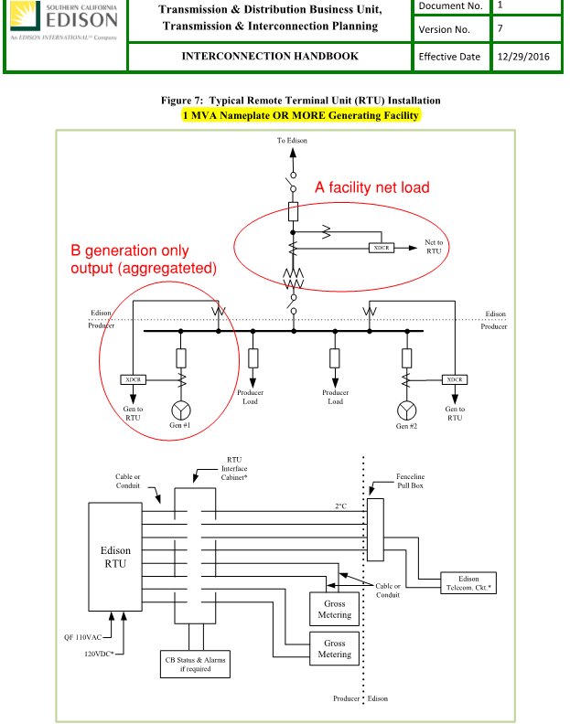

### 

### B. Source of Physical Measurements and Ownership of Measuring Equipment

* Does utility require metering equipment to be utility owned?

*IOU Response: metering cabinets are procured and installed by customer. Metering and CTs are utility installed, owned, and maintained.*

* Does utility require these measurements to come from revenue grade metering equipment? Can source be from producer-owned equipment?

*IOU Response: PG&E does not use an Net Generation Output Meter for Telemetry.*

* When net facility load is required, do utilities always pull net facility load from the existing or new service meter? Can customer set up a connection from that meter to the Remote Terminal Unit or­ Serial Device Server via a serial/RS-485 connection?

*IOU Response: Yes net load if pulled from existing revenue meters.*

### C. Required Sampling Rate

* Is a 1-minute Data Acquisition System feed sufficient, or does the utility require a higher sampling rate?
* What latency limitations or “all-in” sampling rate does the utility have? (e.g. all-in means actual sampling as well as latency occurring in transferring data to Serial Device Server or Remote Terminal Unit)

*IOU Response: TBD*

### D. Bridging Connection – Measurement Source to Facility Terminal

* For connection between metering equipment and/or customer owned Data Acquisition System data logger, what mediums can the customer use to transfer this data to the Serial Device Server or Remote Terminal Unit? Serial only? Ethernet?
* For inverter outputs spread across a campus, can radio signal be used for connection back to the Serial Device Server or Remote Terminal Unit? What about a cell modem connection?

*IOU Response: TBD*

### E. Bridging Connection – Facility Terminal to Utility Energy Management System

* Is Remote Terminal Unit required with private leased T1 line?
* Or is Serial Device Server with Virtual Private Network tunnel to Energy Management System sufficient?
* What about utility willingness to consider data provided via a cell modem and web service (no Serial Device Server /mini-Remote Terminal Unit)
* What is ongoing monthly cost to producer to provide this link?

*IOU Response: TBD*

**2. Example All-In Cost Range for Producer to Provide Telemetry**

IMPORTANT POINT: Cost of Ownership (COO) and Income Tax Component of Contribution (ITCC) are calculated separately to ensure consistency and to demonstrate the magnitude of those items.

## Table 2. Estimates of Current and Future Cost - SCE



Note: Producer side costs can be site specific, so actual costs will vary substantially.

## Illustration of Current and Future Cost of Providing Telemetry – PG&E

## >>>HAROLD>>>

## Illustration of Current and Future Cost of Providing Telemetry – SDG&E

## [add?]

## Summary for Comparing Current Costs Across Utilities

* Cost of recloser at $160,000 (including COO and ITCC) is entire cost for PG&E because that includes everything.
* SCE’s serial device server (sometimes called a “mini-RTU”) is only $6,000-12,000 (including COO and ITCC). Addition to that are the cost of making measurements and the hardwire serial connection, as well as the monthly dedicated internet cost. These can be major costs when the solar strings are not adjacent as in a campus or a large parking area.
* SDG&E requires a net generation output meter. Additional costs include a utility metering cabinet on top of their RTU and monthly cost of the RTU connection.

**3. Assumptions for Simple Financial Explanation – Cost burden on project for TOTAL cost of telemetry**

Calculate range of all-in telemetry cost for two system sizes below

[PLACEHOLDER TO BE UPDATED WITH COST ESTIMATES FORTHCOMING]

|  |  |  |
| --- | --- | --- |
| **System Size** | **Example Total System Cost Only** | **Cost Increase for**  **PG&E $160k Recloser** |
| 1 MW-ac | $2MM | 8% |
| 500 kW-ac | $1MM | 16% |
| 250 kW-ac | $500k | 32% |

# Source Data for Utility Components of Current Telemetry Costs

Note that all costs below do not include ~2.25x multiplier associated with cost of ownership & ITCC tax.

## Figure 2. Current Cost of Telemetry in SCE Per Unit Cost Guide

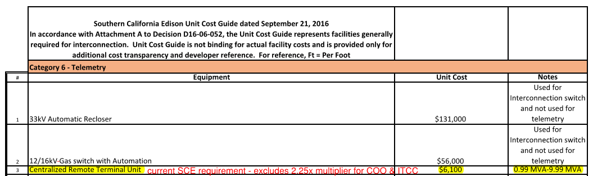

## 

## Figure 3. Current Cost of Telemetry in SDG&E Per Unit Cost Guide

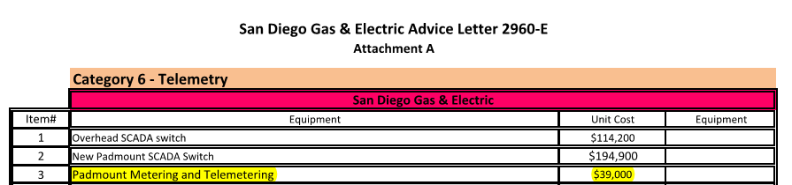

## 

## Figure 4. Current Cost of Telemetry in PG&E Interconnect Study

## >>>HAROLD or PHUOC>>>

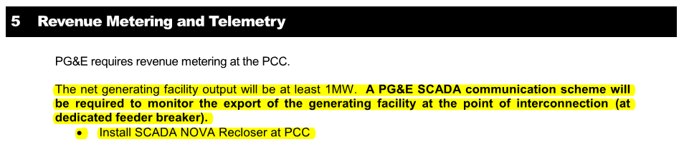

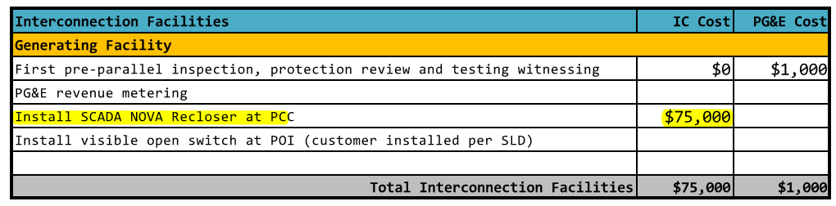

1. The $20,000 cost would include the cost to acquire and transmit real-time generation output data to the utility in compliance with applicable security requirements. It would include O&M and ITCC related costs. It would not include metering costs such as CT’s, PT’s, or generator output meters. For purposes of this proposal these costs as a group are defined as “All-in Costs.”
2. Generating Facility Capacity: The net capacity of the Generating Facility and the aggregate net capacity of the Generating Facility where it includes multiple Generators.
3. Rule 21 Section C (Definitions)
4. Generating Facility Capacity: The net capacity of the Generating Facility and the aggregate net capacity of the Generating Facility where it includes multiple Generators.
5. The $20,000 cost would include the cost to acquire and transmit real-time generation output data to the utility in compliance with applicable security requirements. It would include O&M and ITCC related costs. It would not include metering costs such as CT’s, PT’s, or generator output meters. For purposes of this proposal these costs as a group are defined as “All-in Costs.”
6. As discussed within Working Group discussions, discussions remain underway in support of Smart Inverter Working Group, including forms and agreements that would address aggregator or aggregator akin use in support of Smart Inverter capabilities. These discussion is slated for additional discussion within Working Group Two. For purposes of this proposal, refined telemetry solutions have been focused upon and their associated cost.